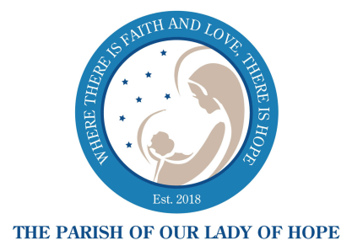

254 Wall Street
W. Long Branch, NJ 07764
Phone: 732-222-1424 Fax: 732-222-2291

Marriage Preparation Timeline and Checklist

BRIDE: _________________________ GROOM: _____________________________

Contacts:
Wedding Coordinator: Pat Carvalho pcarweddings@gmail.com – 848-466-0807
Deacon Lou: shawdowlakekids@aol.com – 732-741-2620
Georgie Mandica: office@ladyofhopeparish.org – 732-222-1424
Father PJ: fpj@ladyofhopeparish.org

- Date of Initial Interview ____________________
Sign and date wedding guidelines
Dispensation/Permission needed? __________________________________
Initial Installment of Church Fee ($300 made payable to Lady of Hope Parish)
Choose an organist: Rob MacReynolds – arrowkeys@robmac88.org 732-685-7944
Mary Zeffiro – marysingsforjesus@gmail.com 732-939-0596
Chris Adams – csadams@csadams.com 732-807-5665

- Schedule Pre-Cana (at least nine months before wedding date)
Check Diocese of Trenton’s website for schedule at dioceseoftrenton.org/precana

- Contact Deacon Lou to sign up for FOCCUS (schedule at least six months before wedding date)
Submit Baptismal Records w/Notations to the Parish Office

- Contact Deacon Lou for Second Interview (schedule at least three months before wedding date)
Discuss FOCCUS results
Submit Pre-Cana Certificate
Second Installment of Church Fee ($300 made payable to Lady of Hope Parish)

- Contact Parish Office to schedule Third Interview with pastor (schedule at least one month before wedding date) to discuss:
Wedding Liturgy Plan
Reading selections
All Paperwork should be received by the Parish Office at this time, including Form C-1 (Residence of
the Couple After They Are Married)
Submit Final Installment of Church Fee ($300 made payable to Lady of Hope Parish)

- Apply for Marriage License (two weeks before wedding date)
If convalidating marriage, need Certificate of Remarriage from town

- Rehearsal Date and Time: ______________________
Bring Marriage License

- Wedding Date and Time: _________________________
SMILE and RELAX, YOU’RE ON!!

